**WriteAway: Information for Instructors**

WriteAway provides asynchronous formative feedback for undergraduate students at participating institutions. Students can submit up to three drafts of a paper to WriteAway, and tutors will provide **strategies and resources** to help improve students’ writing.

**What are the Benefits for Students?**

* Students engage in the revision process. Tutors do not copyedit or add content, but suggest strategies to improve writing skills and help students recognize issues they can fix themselves.
* 24/7 asynchronous availability means students are not restricted to on-campus service hours to access writing assistance.

**What Feedback do Students Receive?**

Tutors provide formative feedback with an emphasis on Higher Order Concerns. Tutors may also comment on Lower Order Concerns.

Higher Order Concerns

* Following Assignment Instructions
* Thesis
* Structure/Organization
* Introduction
* Conclusion
* Paragraph Structure
* Use of Evidence
* Integration of Sources
* Clarity and Flow (Coherence)
* Transitions

**How does WriteAway Work?**

Lower Order Concerns

* Style and Voice
* Grammar
* Punctuation
* Mechanics
* Sentence Structure
* Format

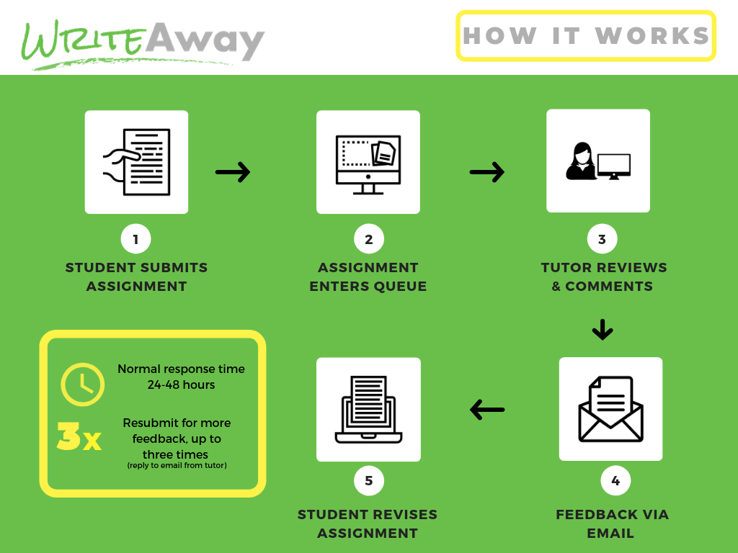

**Who Participates?**

WriteAway has 19 institutions participating as of Winter 2021:

* + Alexander College
  + BC Institute of Technology
  + Camosun College
  + Coast Mountain College
  + College of New Caledonia
  + College of the Rockies
  + Douglas College
  + Kwantlen Polytechnic University
  + Langara College
  + North Island College
  + Northern Lakes College
  + Northern Lights College
  + Selkirk College
  + Simon Fraser University
  + Thompson Rivers University
  + Trinity Western University
  + University of British Columbia
  + University of the Fraser Valley
  + Vancouver Community College

**Who are the Tutors?**

* Tutors are senior undergraduates, graduate students, instructors, faculty, and academic support staff from participating institutions. Tutors meet a set of competencies and undergo training to staff the service.

**What do students say about WriteAway?**

"*This [service] is fantastic! It is easy for me to get people to read papers for grammar, but it is more difficult to get feedback on the paper as a whole. The tutor found key areas for me to improve on and the feedback came back super fast! I will definitely be using this again.”*

*“[My tutor] provided some excellent feedback regarding my essay. I will definitely return to WriteAway as I appreciated how [my tutor] helped fine-tune my essay without rewriting it.”*

*“I feel more confident in my writing because of WriteAway. I now understand that no paper is perfect on the first try, so being able to have someone help push me in the right direction means I’m not hesitating to write my first draft.”*

*“[WriteAway] has improved how I write my papers, as I remember the feedback and apply it to the first draft so I have less editing to do. It has pushed me to finish my papers early, as then I can get additional feedback from WriteAway and make the needed changes to get the highest grade possible.*

**Let your students know about WriteAway!**

* **Include information about the service in your syllabus and link to writeaway.ca on your course website.**
* **Remind students they can receive feedback from WriteAway on their assignments before they submit.**

**For more information about WriteAway**:

Contact your local institutional coordinator:

(IC NAME, EMAIL, PHONE NUMBER)

Visit the [writeaway.ca](http://writeaway.bceln.ca/) website

Contact the WriteAway Administrative Centre: office@writeaway.ca