**Intro to GIS for URB 670**

Sarah Zhang

Librarian for Geography, GIS, & Maps, SFU Library

2022 Spring

1. **Login to ArcGIS Online**

Navigate to [www.arcgis.com](http://www.arcgis.com) and sign in

1. **Add a data layer on ArcGIS Online**

* Click on “**Map**”, which will direct you to the Map Viewer.
* click on the Menu **Add**- **Add Layer from Web**, and copy and paste this URL: <https://services.arcgis.com/E5vyYQKPMX5X3R3H/arcgis/rest/services/DA_boundaries_Vancouver/FeatureServer>
* You will be prompted to choose an attribute to show. Pick “**show location only**” from the drop-down menu. You will see the data is loaded:

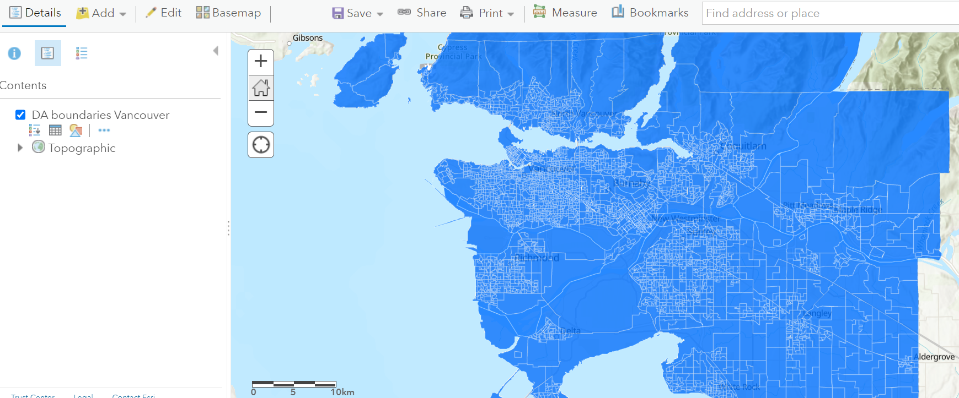

* From your left, under the layer DA boundaries Vancouver, click on the “**Show Table**” icon:

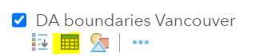

You will then see a table showing up under the map. This spreadsheet is called “**attribute table**”, which is an important GIS concept. Try clicking on one of the rows and seeing what happens.

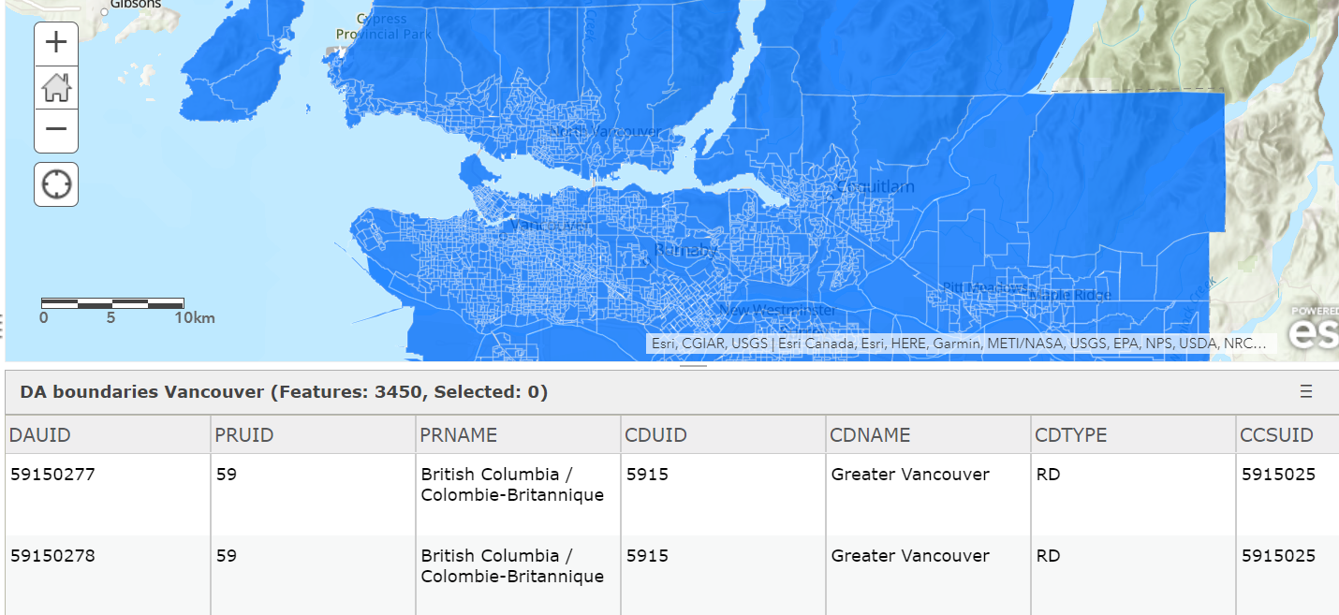

1. **Add another data layer with visible minority people numbers**

Till now, you can’t yet visualize the number of visible minority people on the map, because there is no attribute for visible minority people in this table. So, the next step is to add that data (the csv file you have downloaded) to this shape file.

This is something called **Join** in GIS. I’ve done the Join and put the shape file on Esri’s server for you to use.

* + Click on the Menu **Add**- **Add Layer from Web**
  + Copy and paste this URL:

<https://services.arcgis.com/E5vyYQKPMX5X3R3H/arcgis/rest/services/DA_boundaries_VMinority_Vancouver/FeatureServer>

You will see this layer has been added to your Map Viewer.

* + Switch off the layer **DA boundaries Vancouver**.
  + Click on the new Layer **DA boundaries VMinority Vancouver**, then click on the Show Table icon beneath it. Scroll the table to reveal all the columns. Have you noticed the new attributes?

1. **Making a proportional symbol map**

* Click on the “**Change Style**” icon below the Layer **DA boundaries VMinority Vancouver.**
* **Choose an attribute to show:** pick **Visible_minority**, which is the total number of minority people for each DA.
* Select a **drawing style**:

**Counts and Amounts (Size)** shows as the first one, pick it.

* Click on the **Options**:

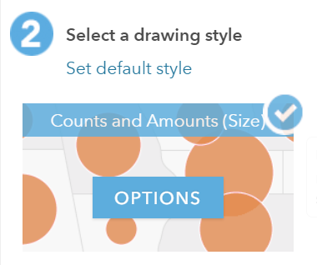

* Check the box “**Classify Data**” and leave the default with **4 classes** as is.

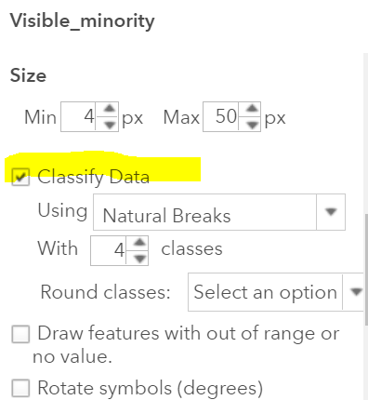

* Click “OK”- “Done”, you will see a map like this (after zooming in on an area):

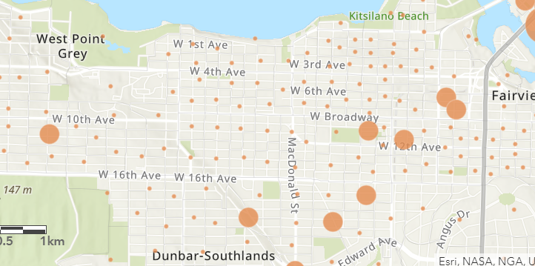

* To make the map more readable, let’s see if we can add the DA boundaries to it. Check the box next to the layer “**DA boundaries Vancouver**”- “**Change Style**” icon below it, click on “**Options**” under Select a drawing style.
* Click on “**Symbols**”

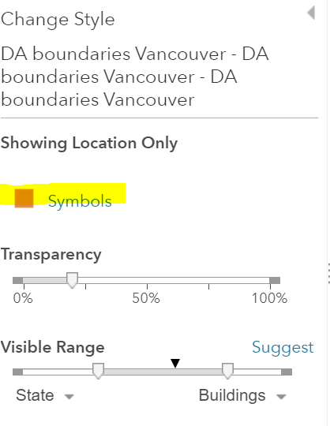

* Change the “**Fill**” color to clear,

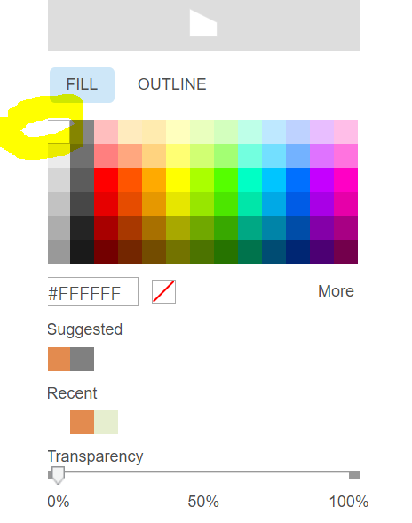

* Change the “**Outline**” color to something not clear, like red or black.

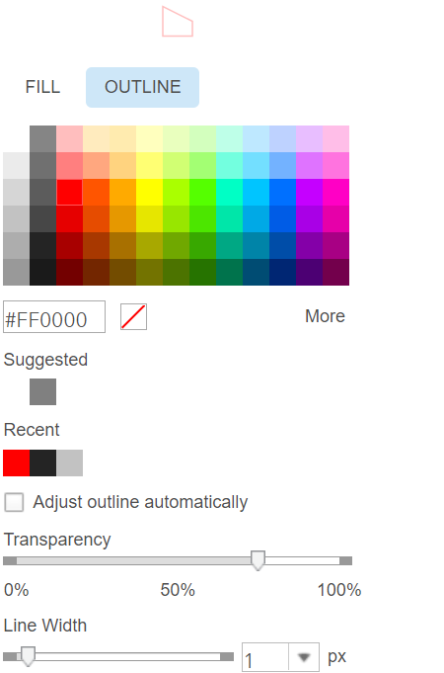

* + Click on “Done”, and you will see the map with the DA boundaries:

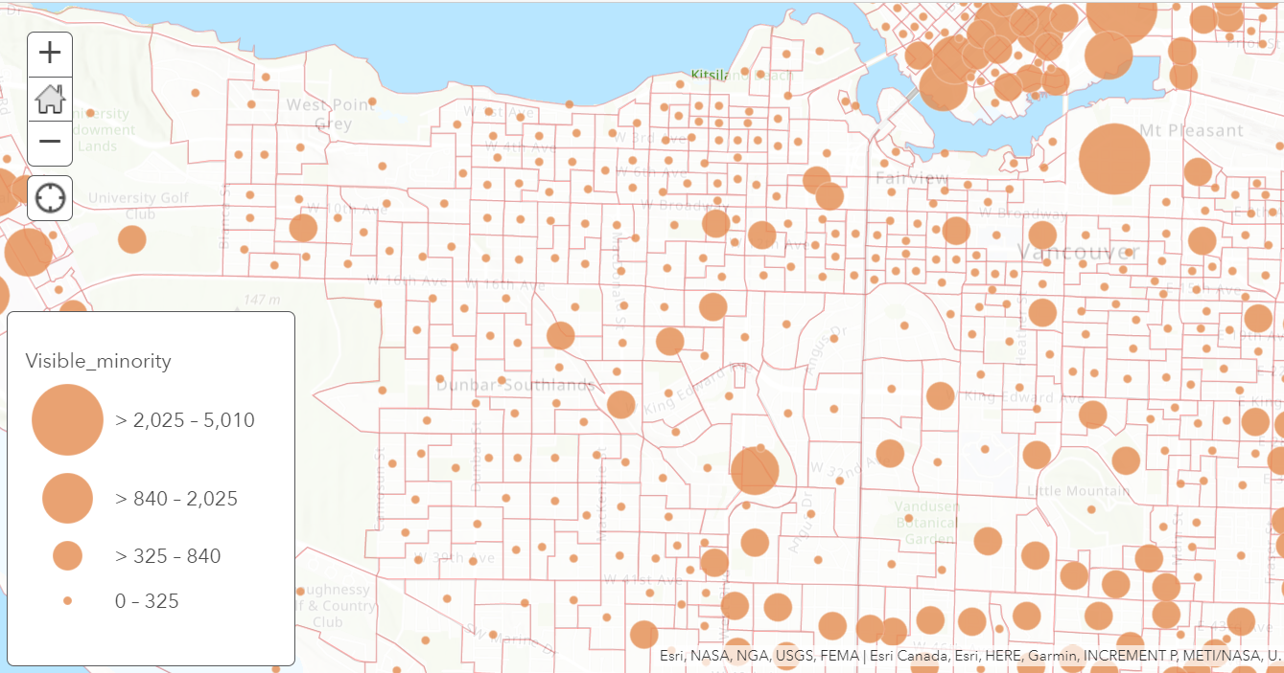

This type of map is called “**Proportional Symbol Map**”

Now, pause here for a second, do you think it’s right to map the total number of minority people for each DA?

1. **Mapping the percentage of minority people**

* Click on the “**Change Style**” icon below the Layer **DA boundaries VMinority Vancouver.**
* **Choose an attribute to show**: pick **Vminority_Percentage,** which is the percentage of minority people for each DA.
* Select a **drawing style**:

**Counts and Amounts (Color)** shows as the first one, pick it.

* Click on the **Options**:

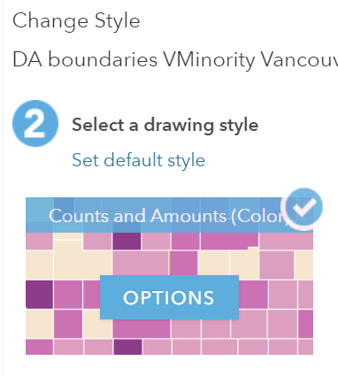

* Check the box “**Classify Data**”, and leave the default **Using Natural Breaks**, and **4 classes** as is.
* You will then see a map like this:

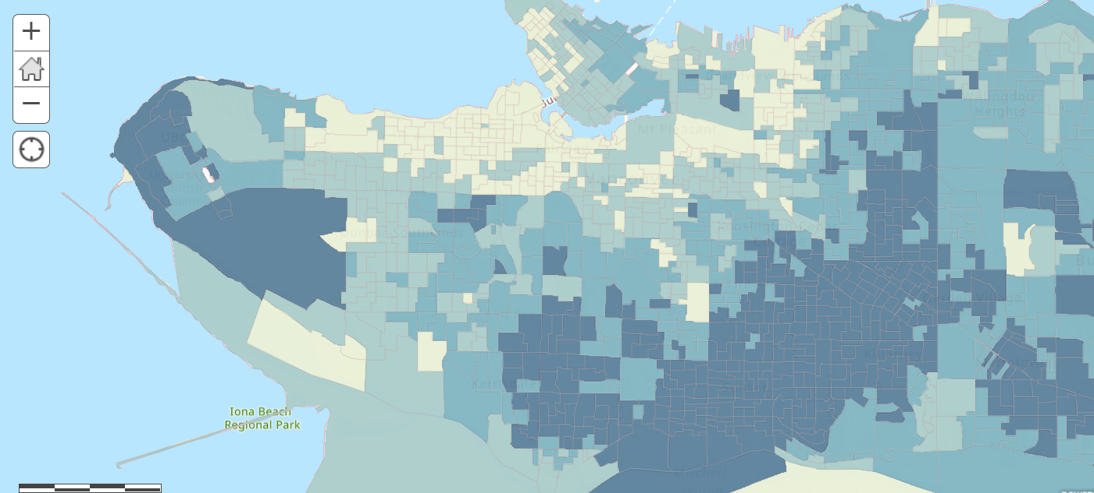

1. **Spatial analysis**

* Under the layer DA Boundaries VMinority Vancouver, click on the **Filter** icon, set your parameters like this:

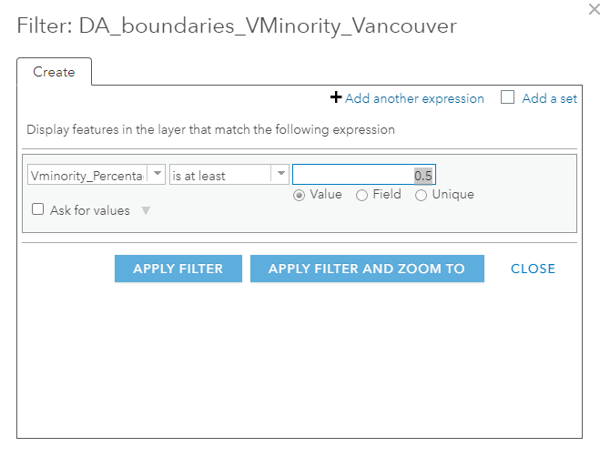

* Click on **Apply Filter**, you will see the layer looks like this now:

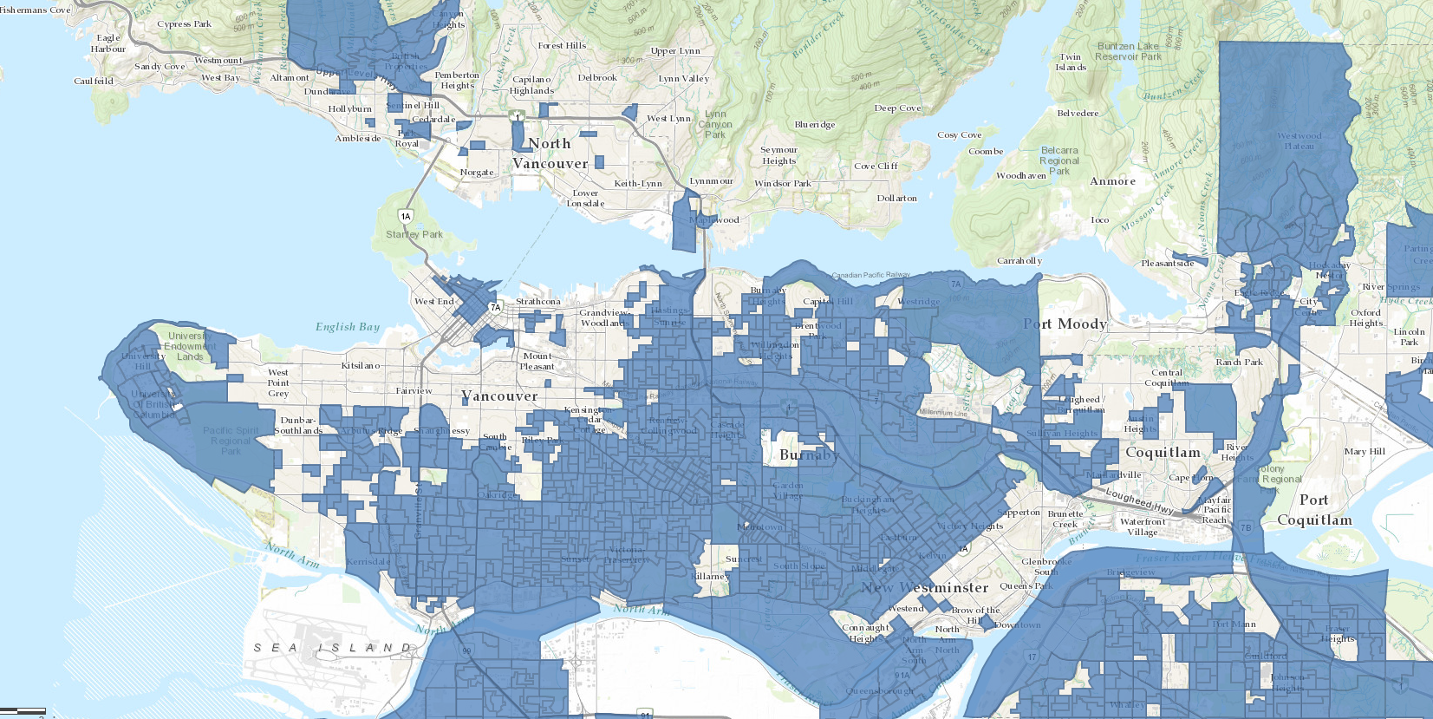

**Appendix: Data resources and preparation**

1. The Geographic file (shape file) for the DAs

The DA (Dissemination Area) boundaries file was downloaded from Statistics Canada’s website: <https://www12.statcan.gc.ca/census-recensement/2011/geo/bound-limit/bound-limit-2016-eng.cfm>

Choose ArcGIS (.shp) as the file format, and Cartographic Boundary File for Dissemination areas.

Given the large size of the file (it includes all the DAs for the entire country), QGIS (a free and open-source GIS software) was used to extract only the DAs in Metro Vancouver from the shape file. This is a two-step process: first select features by attribute table, and second save the selected features to a new shape file. If you wish to learn about this process, refer to this guide: <https://www.qgistutorials.com/en/docs/working_with_attributes.html>

1. Visible minority people and population in Greater Vancouver

The dataset (.csv format) was downloaded from [CHASS Canadian Census Analyzer](https://databases.lib.sfu.ca/record/61245148760003610/Canadian-Census-Analyser), a database provided by the SFU Library. The data is also publicly available from Stats Can’s website <https://www12.statcan.gc.ca/census-recensement/2016/dp-pd/prof/index.cfm?Lang=E> , but you may have to spend some time formatting the data in a format that allows easy mapping.

If you wish to add the data to ArcGIS Online yourself instead of using the URLs, you can download the datasets here: <https://1sfu-my.sharepoint.com/:f:/g/personal/rcommons_sfu_ca/EoSYUW1mTE9ElAhWYJfVuUkBMVg2WbL7pqiewwm3BlHTOA?e=jIQZKn>

**Notes on software**

Please note that ArcGIS Online, while user-friendly and easier to learn, offers less analytical power or cartographic options than Desktop GIS applications, for example, ArcGIS Pro or QGIS.