SFU Library - Catalogue Search Tips

Search for a known book, a journal, or a film
- Click on: “Catalogue Search” / Catalogue / Advanced Search /
- Sign in with SFU Computing ID & password
- Enter: book title, journal name, or film title.
- Limit Material Type” to: “Books”. “Journals”, or “Audio Visual”

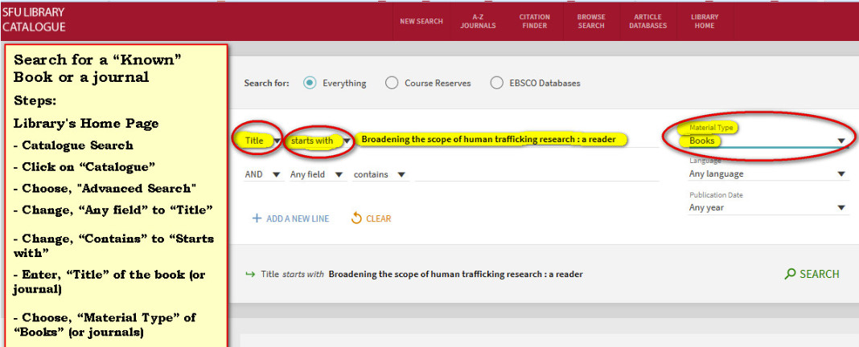

Search syntax for Library Catalogue Search:
- To combine synonyms (same or similar meaning), use a capital “OR”
- To combine different concepts, use a “capital AND”
- When two words are placed next to each other, Catalogue Search automatically searches them using an “AND”
- Same results would be obtained with both of the following:
human traffick*
… human AND traffick*
Wrong Syntax: (human traffick* or forced labour)
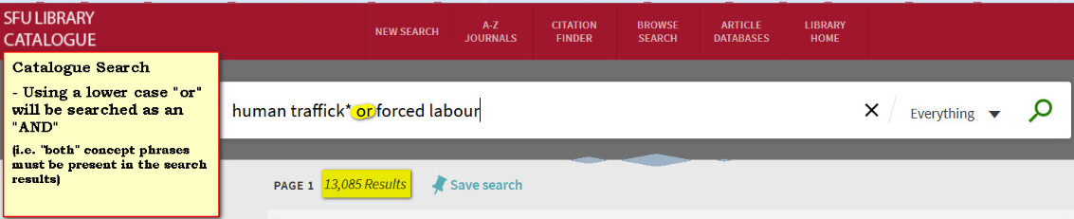
Note: The above results list is very small. If capital “OR” is not used, then the engine brings back results for:
human and traffick* and force and labour
Right Syntax: (human traffick* OR forced labour)
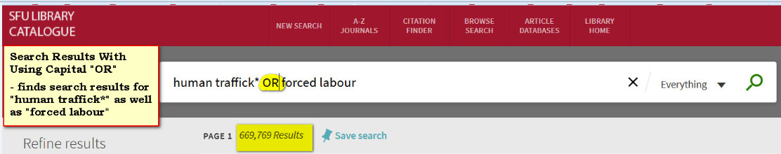
Note: The results list brings back items which have either of the above two concepts.
Right Syntax When Searching for Two or More Concepts
(human traffick* OR forced labour) AND (women OR child*)
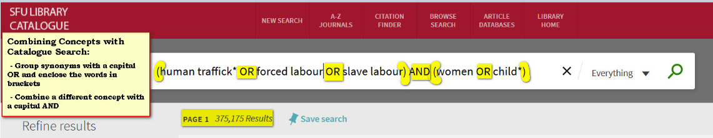

Browse the Library Catalogue
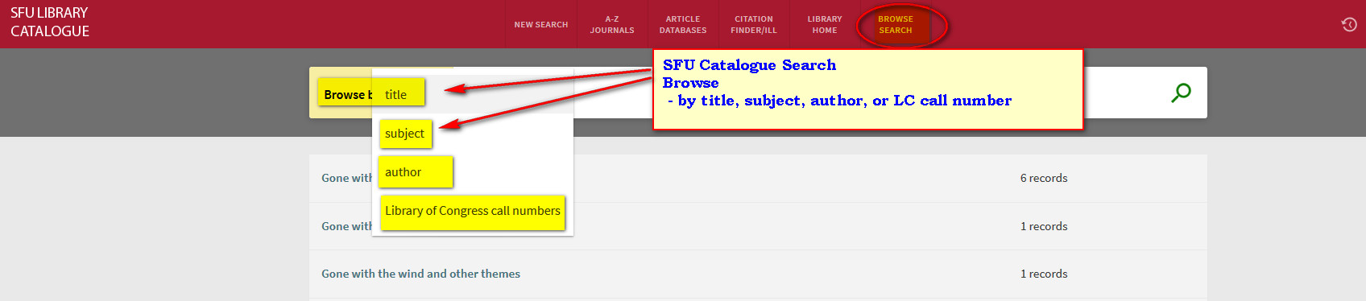

For Access to Electronic
Sign in with SFU Computing ID/Password for access to SFU’s electronic resources.

  - View your Library record (to renew books online)
  - Place a hold on a book that is signed out
  - Transfer a book from another branch
  - Request an Inter-Library Loan
  - Create an E-Shelf of favorite books
  - Set up email alerts of your searches

Links
1. Catalogue Search (books, articles, films): https://sfu-primo.hosted.exlibrisgroup.com/primo-explore/search?vid=SFUL&sortby=rank
Library Catalogue Search Guide: http://www.lib.sfu.ca/find/books-media/catalogue-search-guide
2. Obtain books and articles from other Libraries (use Inter-Library Loans” (ILL) Request Form):
http://www.lib.sfu.ca/borrow/request-materials/ill/request-form
3. Writing help -> Student Learning Commons: http://www.lib.sfu.ca/about/branches-depts/slc
4. Services for you: http://www.lib.sfu.ca/about/overview/services-you
5. Subject Guides by Discipline: http://www.lib.sfu.ca/help/research-assistance/subject
===============================================================================================

