Market Research Approaches & Resources
Student Marketing Association – Fall 2017
1. Why do you think the following two market size estimates are so different?
a. Euromonitor International: 128,408,300 units of wearables estimated to be sold worldwide in 2017.
* Retrieved Oct. 5, 2017 from Euromonitor’s Passport database at SFU Library
b. “Gartner, Inc. forecasts that 310.4 million wearable devices will be sold worldwide in 2017”
* Press release: Aug. 24, 2017. Online: http://www.gartner.com/newsroom/id/3790965
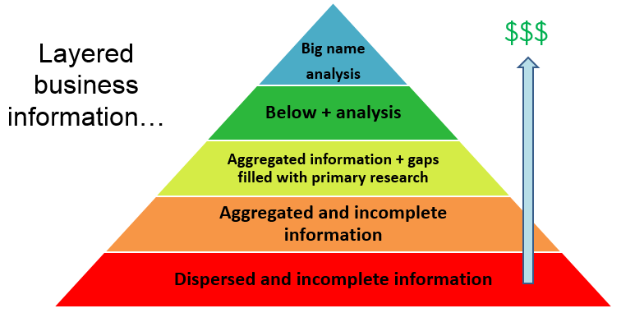
____________________________________________________________________________________________________________________________________________________________

2.

_______________________________________________________________________________________________________________________________________________________________________________________________________________________________________________________________

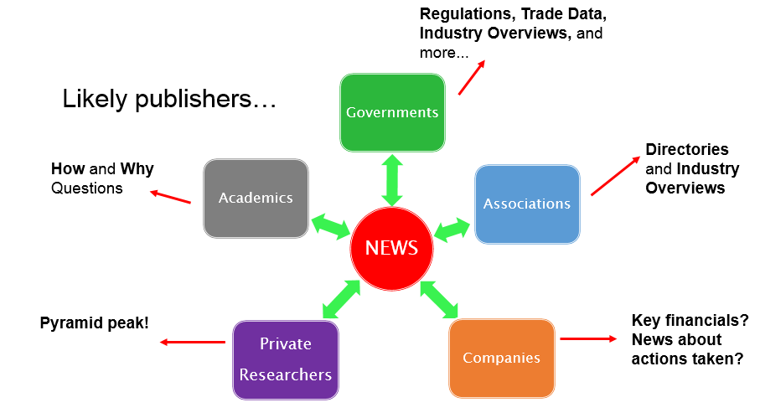
3.

____________________________________________________________________________________________________________________________________________________________________________________________________________________________________________________________________________________________________________________________________________________
4. Foundations for estimates + Bending constraints
____________________________________________________________________________________________________________________________________________________________________________________________________________________________________________________________________________________________________________________________________________________
__________________________________________________________________________________________________________________________________________________________________________
Research Resources

- Starting Points
  - SFU Library > Business > Additional Resources
- http://www.lib.sfu.ca/help/research-assistance/subject/business/additional
  - Small Business Accelerators (UBC)
- http://sba.ubc.ca/
  - Librarians!
2. SimplyAnalytics

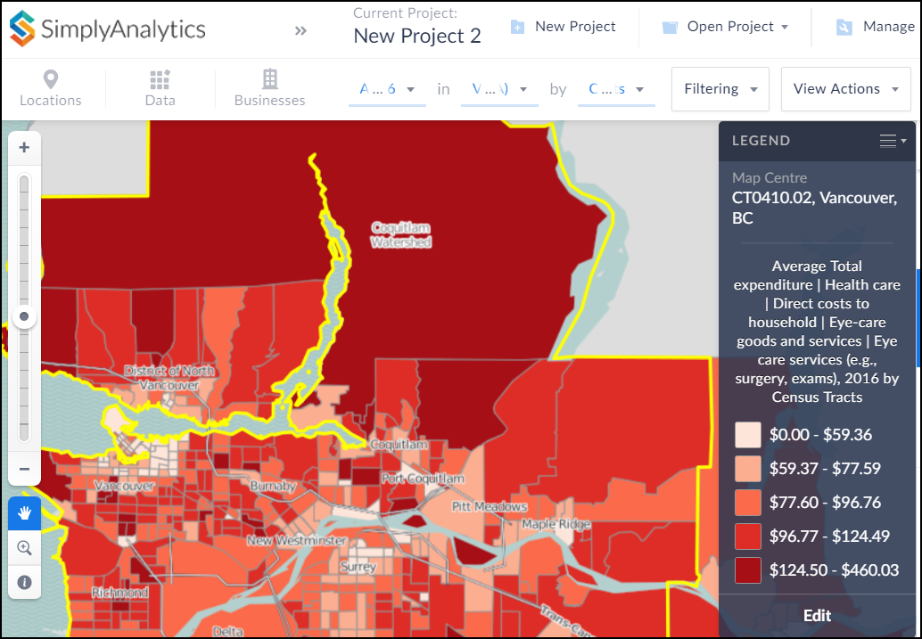
- Map census and spending data, including current estimates and some forecasts, across Canada.
- Map psychographic clusters and business locations.
- Create detailed ring studies and ranked reports
- IBISWorld

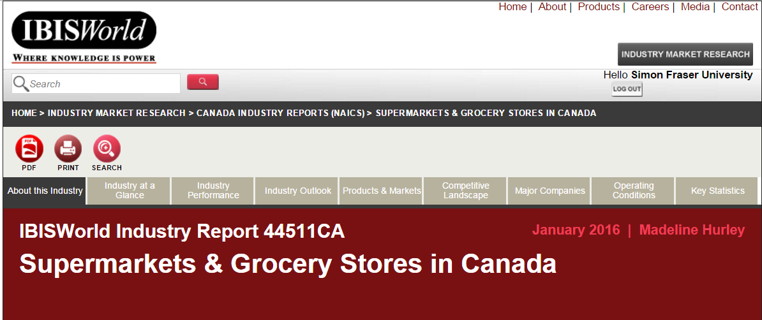
- Industry (not market) reports with strong US/Canada focus.

- Frost & Sullivan

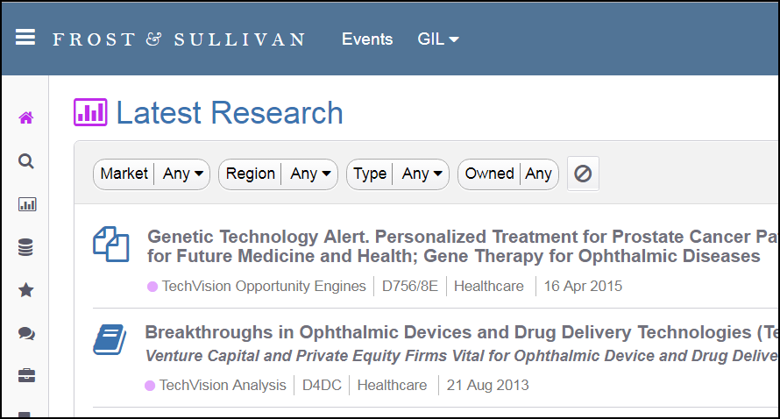
- Market reports on emerging technologies.

- Factiva

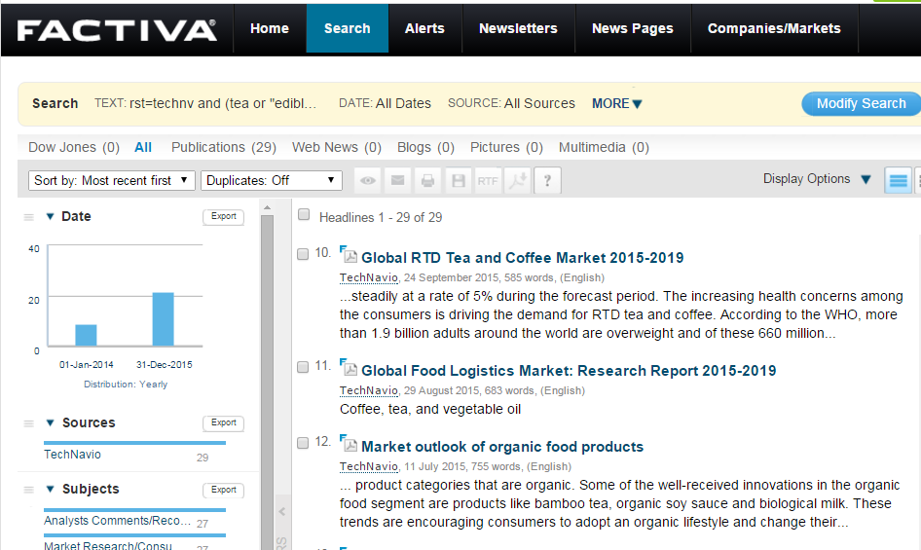
- Includes some hidden gems such as TechNavio market forecasts, but the news content (35,000 sources) is the best feature.

- Passport

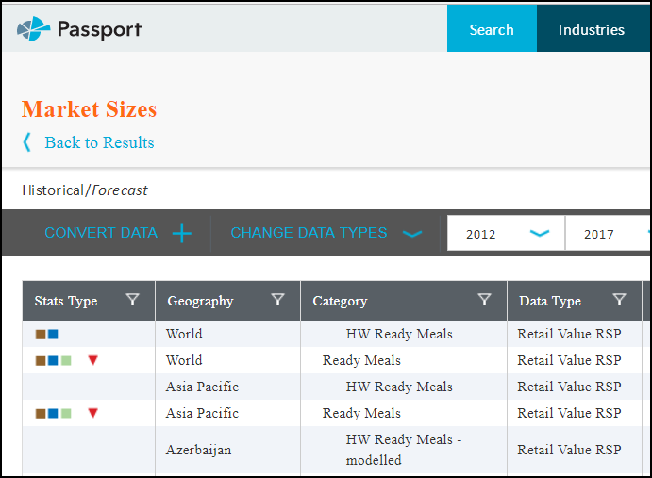
- FMCG market reports and data at a national level for 100 countries.

- Statista

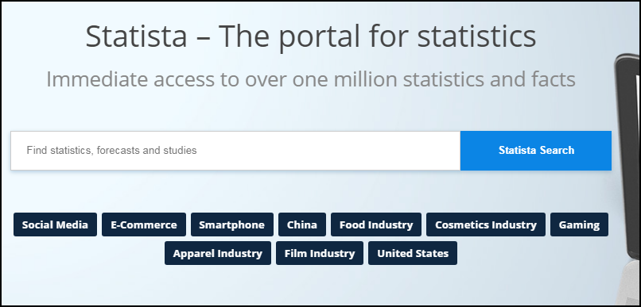
- Fast route to statistics on most marketing topics.
- Can often link out to original sources.
- Other?
____________________________________________________________________________________________________________________________________________________________

