Type or paste the title of the work here
by
[Firstname Lastname]
[Previous degree, institution, YEAR]
[Previous degree, institution, YEAR – if more than one list in descending order]
[Thesis/Project/Extended Essays] Submitted in Partial Fulfillment of the
Requirements for the Degree of
[Master of…/Doctor of…]
in the
[School/Department of …]
[Faculty of …]

© [Firstname Lastname] YEAR
SIMON FRASER UNIVERSITY
[Term YEAR]

Copyright in this work is held by the author. Please ensure that any reproduction
or re-use is done in accordance with the relevant national copyright legislation.

Declaration of Committee
Name: | [Firstname Lastname]
Degree: | [Master of …/Doctor of …]
Title: | Type or paste the title of the work here
Committee: | Chair: | [Firstname Lastname]  [Academic Role, Academic Unit]
[Firstname Lastname]
Supervisor
[Academic Role, Academic Unit]
[Firstname Lastname]
Committee Member
[Academic Role, Academic Unit]
[Firstname Lastname]
Committee Member
[Academic Role, Academic Unit]
[Firstname Lastname]
Committee Member
[Academic Role, Academic Unit]
[Firstname Lastname]
Committee Member
[Academic Role, Academic Unit]
[Firstname Lastname]
Examiner
[Academic Role, Academic Unit]
[Firstname Lastname]
External Examiner
[Academic or Professional Role, Academic Unit]
[Institution]

Please review the Declaration of Committee page instructions on the library’s thesis website before completing this page:
https://www.lib.sfu.ca/help/publish/thesis/format/declaration-committee
Remember to delete this note before submission.

Ethics Statement
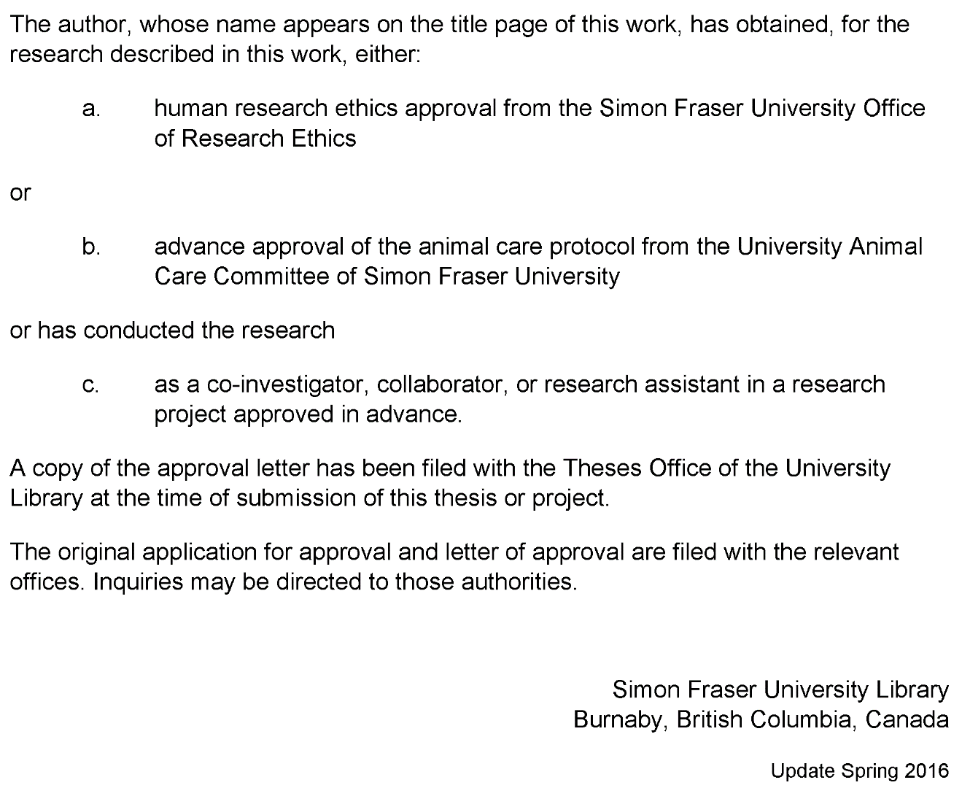
This page must appear as p. iii if your research required ethics approval. Remember to delete this note before submission.
If an ethics exemption was granted, this page must be removed.
If ethics approval was not required, this page must be removed.
Remember to update the Table of Contents after removing this page.

Abstract
Abstract paragraphs should be unindented: use the style 1_Para_FlushLeft. Master’s abstracts are limited to 150 words; the limit is 350 words for doctoral abstracts. Abstract text must fit on a single page. Keywords may appear alone on a second page.
You may include up to six keywords or phrases. Keywords should be separated with semicolons.
Keywords: thesis template; Microsoft Word; keywords; 1” hanging indent; instructions

Dedication
This is an optional page. Use your choice of paragraph style for text on this page (1_Para_FlushLeft shown here).
To hide the heading at the top of this page, select the text and change the text colour to white.

Acknowledgements
This is an optional page. Use your choice of paragraph style for text on this page (1_Para shown here).

Table of Contents
Declaration of Committee ii
Ethics Statement iii
Abstract iv
Dedication v
Acknowledgements vi
Table of Contents vii
List of Tables viii
List of Figures ix
List of Acronyms x
Glossary xi
Preface/Executive Summary/Image xii
Chapter 1. Introduction 1
References 2
Appendix A. An Example of an Appendix 3

List of Tables
No table of figures entries found.
Use References>Insert Caption to create caption labels and numbers. Right-click on the text above and select Update Field to update this list. See the Thesis Template Instructions for information on creating tables, figures, and captions.
Remember to delete this note before submission.
If there are no tables in the document, remove this page.

List of Figures
No table of figures entries found.
Use References>Insert Caption to create caption labels and numbers. Right-click on the text above and select Update Field to update this list. See the Thesis Template Instructions for information on creating tables, figures, and captions.
Remember to delete this note before submission.
If there are no figures in the document, remove this page.

List of Acronyms
SFU | Simon Fraser University
LAC | Library and Archives Canada
 | This is an optional page and can be removed if not used.
 | Use one table row for each item to allow sorting using Word’s table tools.
 | Apply the style 1_Para_NoSpace to table rows as shown here.

Glossary
Thesis | An extended research paper that is part of the final exam process for a graduate degree. The document may also be classified as a project or collection of extended essays.
Glossary | An alphabetical list of key terms
 | This is an optional page and can be removed if not used.
 | Use one table row for each item to allow sorting using Word’s table tools.
 | Apply the style 1_Para_NoSpace to table rows as shown here.

Preface/Executive Summary/Image
This page can be used for a Preface, Executive Summary, or introductory image. This is an optional page and can be deleted if not used.
To hide the heading at the top of this page – e.g., if using an introductory image – select the text and change the text colour to white.
Do not delete the section break that follows this paragraph. If the section break is not visible, turn on non-printing characters using the Show/Hide icon (¶) on the Home ribbon.

Introduction

References
Adams, Alice. (2002). Article Titles : A Qualitative and Quantitative Analysis. Journal of Journal Studies, 23, 189-672. doi:10.1015/0032-002X.56.7.893
Brown, Bob. (2010). Books: Sustainable and Biodegradable Reading Technology. New York, NY: Hydraulic Press. doi:10.1026/0022-005X.52.6.803
Carroll, Carol. (1999, July). Curating Curious Collections: An Interdisciplinary Perspective. Predatory Publishing Quarterly, 16 (5), 3-134.

Appendix A.
An Example of an Appendix
Note: If you have figures or table in your appendices, do not include them in your List of Figures or List of Tables.
Number your figures and tables with the appendix letter e.g. Table A.1. (for the first table in Appendix A) or Figure B.2. (for the second figure in Appendix B).
Remember to delete this note before submission.

