Fill in the blanks

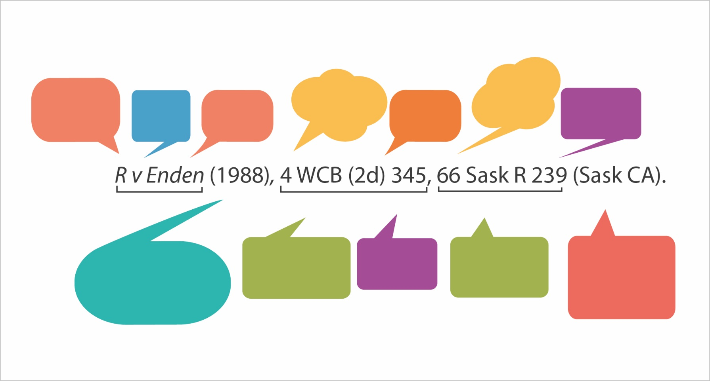

Practice Questions

- CanLII

  - When does continuous coverage start for BC Supreme Court cases in CanLII? Hint: select the Scope of Databases link at the bottom of the page.

  - Using CANLII, locate the decision from the Canadian Human Rights Tribunal issued on December 20, 2013. What is the name of that decision? (Hint: it’s best to browse, not search, for this decision).

    - Locate the BC Employment Standards Act on CANLII. Note that finding legislation within CANLII by searching can be a little tricky.
What is the name of section 25?

    - CANLII allows you to “note up” a case/decision or legislation, which means that you can research which decisions have cited a particular case or piece of legislation of interest. Try doing this with the Employment Standards Act

      - On the CANLII’s web page for the BC Employment Standards Act, navigate to the “noteup” tab towards the top of the page. Select the button, “Noteup a specific section or subsection from this statute” and enter 25. This will show you how many cases cite this particular section of the Act. (Limitation: CanLII will only reference cases that are indexed within CANLII).

How many cases cite section 25 of the Employment Standards Act? Name the first result’s case name, plus the Board, Tribunal or Court the matter was brought before.

WESTLAW NEXT CANADA – TWO LEGAL RESEARCH TOOLS

Part 1: CANLII

- Go back to CANLII. Run a search for unfair employment termination in CANLII. How many cases come up for this keyword search?

Part 2: WESTLAW NEXT

Canadian Abridgment Digest via Westlaw Next

- Please go to the library website and locate the subscription database, WestlawNext Canada.
- From the Westlaw Next home page, select the Canadian Abridgment Digest (CAD), which summarizes and classifies hundreds of thousands of Canadian legal cases.
  - You will first see numerous CAD main headings (example: Aboriginal Law). Please find 3 headings or sub-headings where case law digests of decisions involving labour and employment issues might be found (there are many possible answers). How many cases are classified under each of those headings?

1.
2.
3.

Canadian Encyclopedic Digest via WestLaw Next

- Go back to the main Westlaw Next home page. You will switch from searching the Canadian Abridgment Digest collection to now searching another one of Westlaw Next’s legal research tools: The Canadian Encyclopedic Digest
- Select Canadian Encyclopedic Digest (found under Commentary)
- Here, you can search all of the encyclopedia at once, or browse by alphabetical encyclopedia entries.
    - Scroll down to Labour Law – British Columbia, and click on this entry.
    - Go to section XIV – Economic Conflict
    - Next, go to subsection 10 – Picketing
    - Next, go to sub-sub-section (c) – Permitted Activity
    - Here, you will find a comprehensive statement of the law about permitted picketing activity, based on case law and legislation. You can also use the footnotes to point you to key cases and legislation on this topic.

Section 882 states, “Picketing engages the constitutional value of freedom of expression in s. 2(b) of the Canadian Charter of Rights and Freedoms, which is a higher freedom than protection from economic harm”. According to footnote 5, which major food company was part of a lawsuit which helped establish this statement of law?

EXTRA QUESTION, IF TIME PERMITS

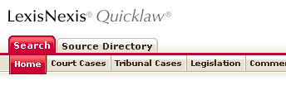
- Quicklaw

  - A journal article found in the McGill Law Journal discusses a Montreal furrier who had grown accustomed to his apprentices fleeing from him. What is the name of this article which, more generally, discusses servants’ rights in the 19th Century?

