Fill in the blanks

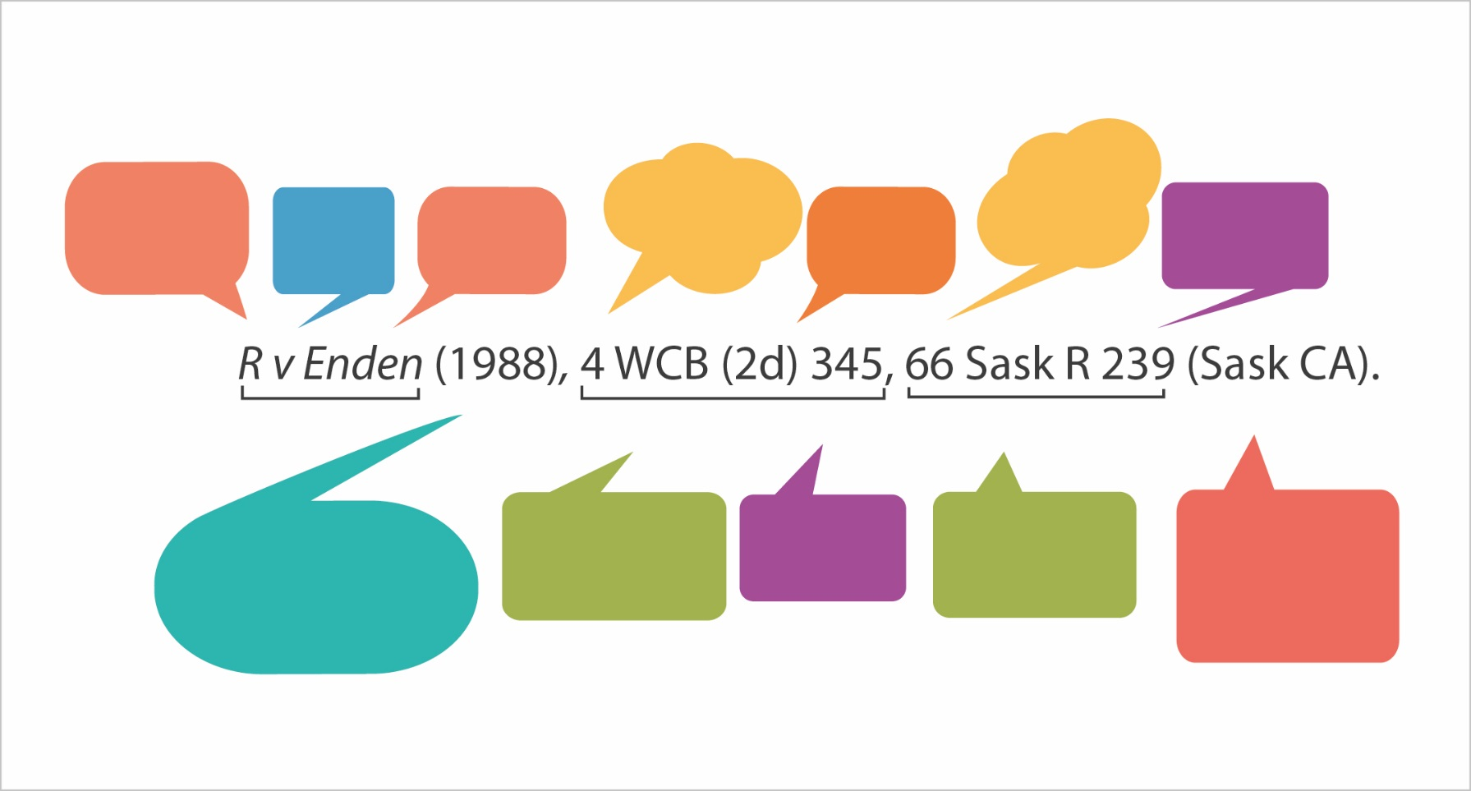

Practice Questions

- CanLII
  - When does continuous coverage start for BC Supreme Court cases in CanLII? Hint: select the Scope of Databases link

  - Search for this case name: Cruise Connections Canada v. Szeto. What is the case’s neutral citation?

  - Using CANLII, locate the decision from the Canadian Human Rights Tribunal issued on December 20, 2013. What is the name of that decision?

- Westlaw Next Canada

  - Under the Commentary section of the database, select “Articles and Newsletters”. You will see a list of various law report articles, legal reviews and journals, and newsletters found in Westlaw Next Canada. One is a journal called Criminal Law Quarterly. An article within that journal discusses the legality of wearing a mask during a protest. Who is the first listed author of that article?

  - Find the case, Bhasin v. Hrynew, 2014 SCC 71, [2014] 3 S.C.R. 495. Which judge wrote the reasons for decision?

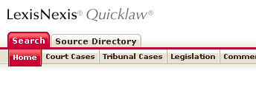
- Quicklaw

  - A journal article found in the McGill Law Journal discusses a Montreal furrier who had grown accustomed to his apprentices fleeing from him. What is the name of this article which, more generally, discusses servants’ rights in the 19th Century?

  - Find the case, Cassells v. University of Victoria.
    - Name an Act cited in this case. (Several possibilities)
    - Note up the case. How many other cases “mentioned” this case?

